**Software development team:**

<https://github.com/V587MRZ/Portable-Electroluminescence-Measurement-System>



*Fig 1: Test picture with no hand*

The image is captured to avoid the background noise, when the Electroluminescence is power off.



*Fig2: Test picture with hand*

This image simulates the Electroluminescence with the power. When the power is on, the solar panel's light parts indicate no fault, while the dark parts mean the connection breaks.



*Fig 3: Final image after subtracting both images.*

Using the second image subtracts the first image, to eliminate the effect of the background noise. Converting it to grey image, we are easily to detect the fault parts of the solar panel.

**Electrical Development team:**

The initial circuit was created on a software called “MPLab Mindi”.

*Fig 4: First version of circuit on MPLAB Mindi.*

The reason why this software was initially chosen was because LT spice did not have a schematic for the HV9910C chipset that we intended to use as the main part of the circuit. Due to the software not being efficient and feature rich enough to satisfy our requirements.

The conceptual circuit for the current limiter was then built on LT spice. The goal of the circuit is to vary the amount of current that will pass through the panel so as to be able to test a variety of panel sizes without the need to change the circuit.

The image below is the first iteration of the circuit. This circuit was created with the help of Chris Jones. We were able to achieve a limiting current of 10A, which is the requirement of the client.

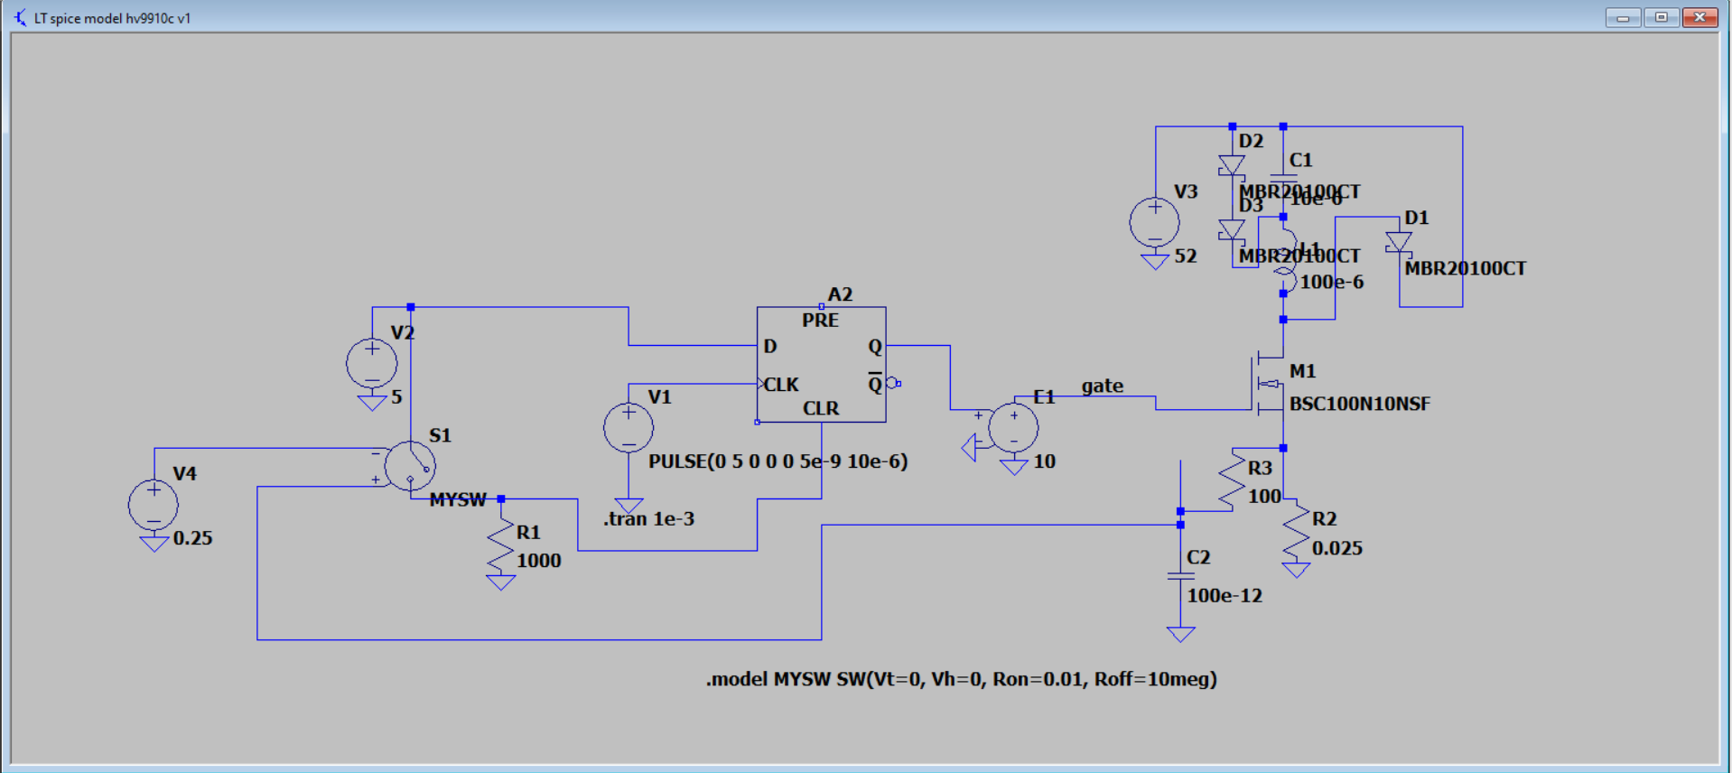

*Fig 5: Initial circuit design on LT spice*

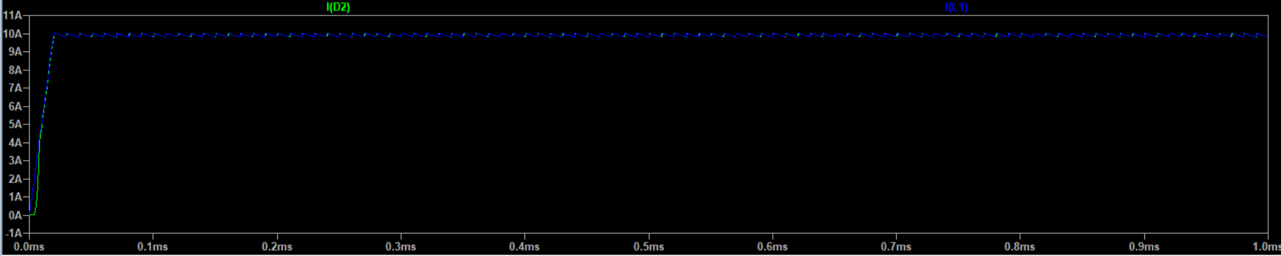

*Fig 6: Output of the initial circuit design*

While sourcing out components for the circuit, we encountered an issue where the parts that supported a value of 100 micro henrys could not support the required current that we needed. So in order to tackle this issue, we had to remake the circuit to accommodate for this issue.

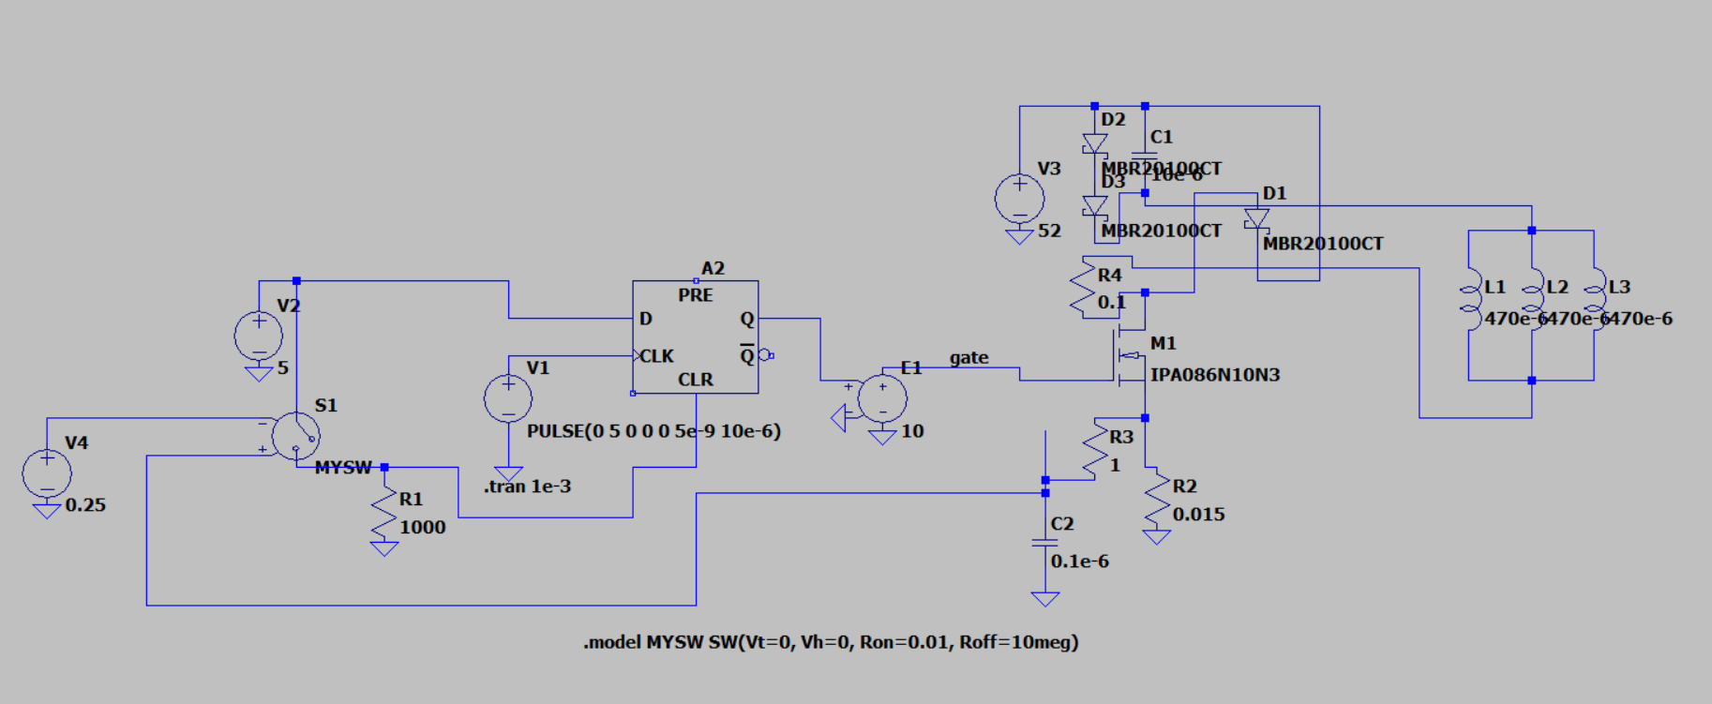

*Fig 7: New circuit design*

The picture above showcases the new improved circuit, based on available parts that can be easily procured. The number of inductors increased and is kept in parallel since each inductor can only handle a current rating of 5A.

*Fig 8: Output of the new circuit design*

Right now we are in the process of making the [Bill Of Materials](https://anu365.sharepoint.com/sites/PortableELdeviceProject/Shared%20Documents/Repository%20Documents/Documents/Reports/Bill%20Of%20Materials_V1.docx).

**AFTER AUDIT 2:**

The code implements image capture and difference calculation using the Raspberry Pi Camera module for portable electroluminescence measurement system for photovoltaic modules. The purpose of this process is to capture a series of images and compute the difference between consecutive frames. The code allows for both automatic and manual modes of operation, providing flexibility in capturing and analyzing images. The code consists of two parts: the main function and the functional function.

Main Function The main function handles the user input and initiates the image capture and difference calculation process. Here is an overview of the main function:

* It initializes the PiCamera object and retrieves the camera settings such as resolution, ISO, exposure speed, and light gain.
* The user is prompted to select between auto mode and manual mode.
* In auto mode, the user provides the waiting time and ISO value, and the capture_and_diff function is called with the specified parameters.
* In manual mode, the user provides additional parameters such as the number of samples, ISO value, waiting time, resolution, and shutter speed. The capture_and_diff function is called with the provided parameters.

Functional Function (capture_and_diff) The functional function performs the image capture and difference calculation. Here is an overview of the capture_and_diff function:

* It initializes the GPIO settings and the PiCamera object with the specified parameters.
* The function sets up the required configurations for capturing 8-bit raw YUV data.
* The image capture and difference calculation loop is executed for the specified number of photos.

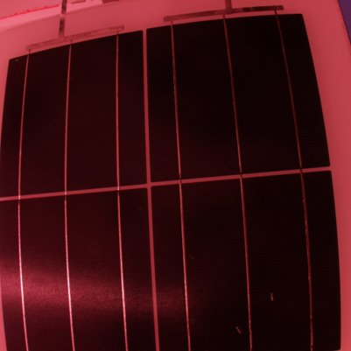

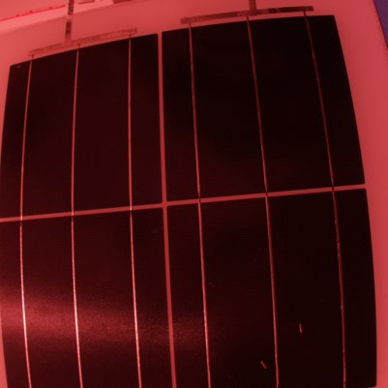

* For each photo, the PiCamera captures the YUV data and converts it to grayscale using the cv2.cvtColor function.
* The difference between consecutive grayscale images is computed using cv2.absdiff.
* The difference images are accumulated in a numpy array for further processing.
* After the loop, the average difference image is computed by dividing the accumulated difference by the number of photos.
* The average difference image is then scaled to the range of 0-255 and saved as "average_diff_image.png".

Conclusion The provided code allows for image capture and difference calculation using the Raspberry Pi Camera module. It provides options for both automatic and manual modes, allowing users to customize the parameters for their specific requirements. The resulting average difference image can be used for further analysis or visual inspection.

The electrical team started creating the physical electrical limiting device, the below table will provide the final parts used and the rating of each part.

|  |  |  |
| --- | --- | --- |
| Part | Description | Rating |
| HV9910C | The main chip that acts as the regulator. | 15V-450V, max temp of 125C |
| Resistor R1 | Resistor that connects to pin 8 of the chip (RT) | 240 k |
| Resistor R2 | Resistor that is used to step down the voltage to 5V | 18 k |
| R3 (potentiometer) | Help adjust the amount of current required. | 1k |
| Resistor R4 | Connected to the potentiometer | 18k |
| Resistor R5 |  | 17k |
| Resistor R6 | A surface mount style resistor | 50m |
| Resistor R7 | A surface mount styled resistor | 50m |
| Capacitor C1 | Connects to pin 6 of the chip (VDD) | 1 |
| Capacitor C2 | Connects to pin 7 (LD) of the chip | 0.1 |
| Capacitor C3 |  | 330 , 63V |
| Capacitor C4 | Connects to pin 1 (Vin) of the chip | 0.1 |
| Capacitor C5 | Added before current enters the panel | 1 |
| Zener diode |  | - |
| Switch | Normal 5V switch to activate the circuit | - |
| MOSFET | Used to connect the chip to the circuit and panel | 100V, 45A rating |
| Diode D2 | Schottky styled rectifier | 100V, 20A |
| Inductor L1 | Toroidal styled inductor | 380 |

The latest schematic of the electrical circuit is shown below.

The circuit is built into a prototyping copper clad board. The prototype is shown in the picture below.

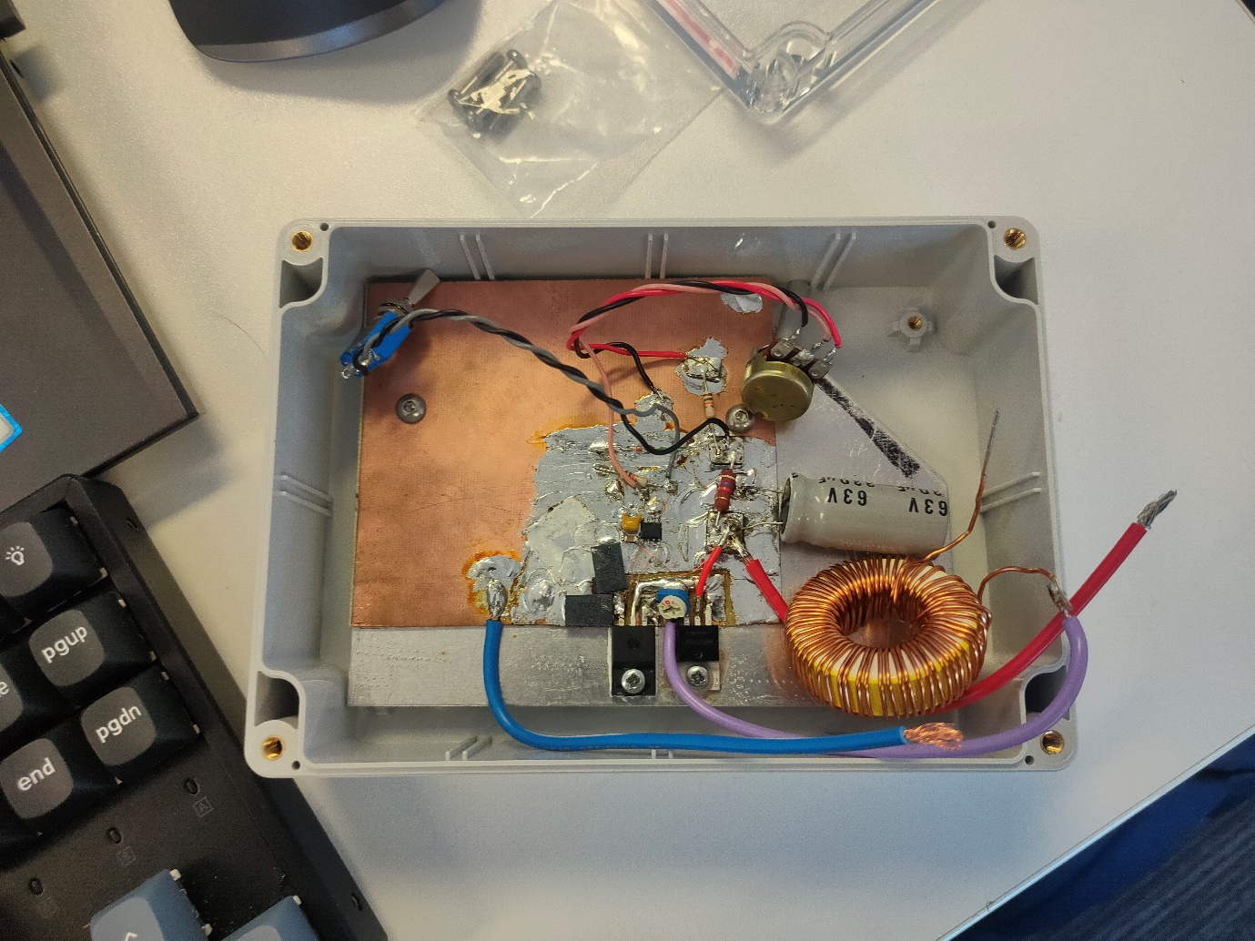

Testing out the prototype with a power source and light bulbs, we can see that we are able to pass around 30v and 9.5 amps of current through the system without any issues. The same testing was done with a 4-cell solar panel that has a rating of 8 amps.

|  |  |
| --- | --- |
|  |  |